**AUTOMATED ATTENDANCE SYSTEM**

**A PROJECT REPORT**

SUBMITTED IN PARTIAL FULFILLMENT OF THE REQUIREMENTS

FOR THE AWARD OF THE DEGREE OF

BACHELOR OF TECHNOLOGY IN

[INFORMATION TECHNOLOGY]

Submitted by:

UTSAV SINGH

2K20/IT/156

Under the supervision of

Asst. Prof. Anurag Chauhan



DIGITAL ELECTRONICS

DELHI TECHNOLOGICAL UNIVERSITY

(FORMERLY Delhi College of Engineering)

CONTENTS

1. Candidate’s Declaration …….……………… 3
2. Abstract ……………………..………………. 4
3. Acknowledgement …………..………………. 5
4. Introduction …………………….…………… 6
5. Approach ………………… ………………… 7
6. Explanation of Code ………………………… 8
7. Screenshots of Working Program ………...… 14
8. Conclusion ……………………………….…. 17
9. Future Scope …………………………….….. 17
10. Documentation of Modules Used …………. 18

**1.Candidates Declaration**

I, Utsav Singh (2K20/IT/156), student of B. Tech. (INFORMATION TECHNOLOGY), hereby declare that the project Dissertation titled “Automated Attendance System” which is submitted by me to the Department of INFORMATION TECHNOLOGY,Delhi Technological University, Delhi in partial fulfillment of the requirement for the award

of the CGPA of 4th Semester for the degree of Bachelor of Technology, is a python based program which is used to automate the process of attendance by using modules such as opencv and pytesseract and the code is original and not copied from any source and the documentations of the modules have been mentioned in this report.

Place: Delhi

Date: 17th April, 2022

Signed by:

Utsav Singh

2K20/IT/156

**2.Abstract**

In our daily lives we can see some form of an attendance system in any school , college or workplace .In most workplaces the salary of employees is affected by the number of working days and students from school and colleges have to get a certain minimum required percentage of attendance to pass. The traditional way of taking the ascendance i.e. by roll call is tedious and time taking if there are a large number of students ,it is also inefficient and commonly noted down in registers/notebook which have to be entered into the database by the teachers later which is very inconvenient.Therefore, as we are moving into the modern era of digitization we need something that is efficient, fast , affordable ,reliable and can be used automate the whole process of attendance for the convenience of both teachers and the student , employees and the employees.

The goal of this project is to create a automated attendance system.

**3.Acknowledgement**

In performing our major project, I had to take the help and guideline of some respected persons, who deserve my greatest gratitude. The completion of this assignment gives me much pleasure. I would like to show my gratitude to Asst. Prof. Anurag Chauhan , Mentor for a major project. Giving me a good guideline for my report throughout numerous consultations. I would also like to extend my deepest gratitude to all those who have directly and indirectly guided me in writing this assignment.

Many people, especially my classmates , have made valuable comment suggestions on this proposal which inspired us to improve my assignment. I thank all the people for their help directly and indirectly to complete my assignment. Also, I would like to thank, Department of Information Technology, Delhi Technological University for allowing me to work on this topic.

**4.Introduction**

The goal of this project is to create an automated attendance system which can be used to automatically mark and store the attendance of DTU students in the form of excel sheets which can be easily accessed and modified.

The plan is to create a robust system where only DTU students of a specific batch attending a specific class can mark their attendance and there will be no way to cheat the system and get free attendance .

Once the program is started , the user (most likely the Professor or the CR ) will be asked to select the batch and the course whose attendance is to be taken based on that information the program will first access the specific excel sheet of that batch and then allow students to mark their attendance.

The students will be able to mark their attendance by showing their valid ID cards to the camera(webcam of the computer the program is run) then the program will extract the student roll number from their ID card and mark the their attendance in the excel sheet ,once this process is completed a confirmation message will be displayed to the student.

**5.Approach**

First we will need a way to access the camera (webcam) of the computer and then use it to take pictures of the ID card when it is showed to the camera by the student.

This will be done by the **OpenCV** module in python that has functions to access camera and perform various operations.

But before extracting the roll from the ID we need to first perform some operation on the image to remove useless information and make the process of extraction faster.

First we will crop to ID card photo to the part which only contains the Roll number then we will convert the image to greyscale and sharpen the image to improve the predictions.

Now that we have decreased the size of our data we will need a way to actually read the characters from the image are return us a string . This will be done by the **pytesseract** module which will provide an ocr model that is light weight and fast and meets our requirements.

Once we get the contents of the ID card in string format we will search for the DTU Roll number .Once the roll is acquired we can mark the attendance in the excel sheet.

To work with the excel sheets **openpyxl** module is used which has various functions to work with excel sheets.

**6.Explanation of Code**

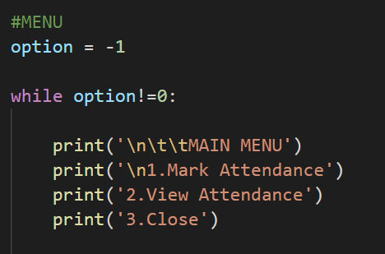

When the program is started the user is greeted with a menu , here user can decide to mark attendance or view the attendance of a batch or close the program . Based on the user decision sub menus are opened.

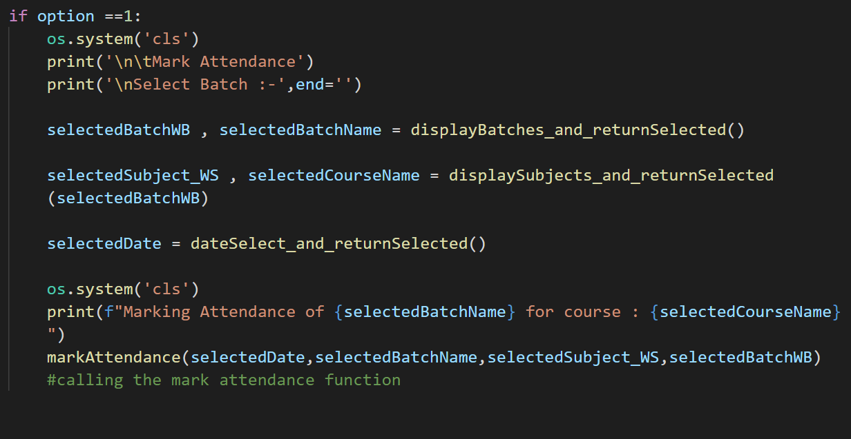

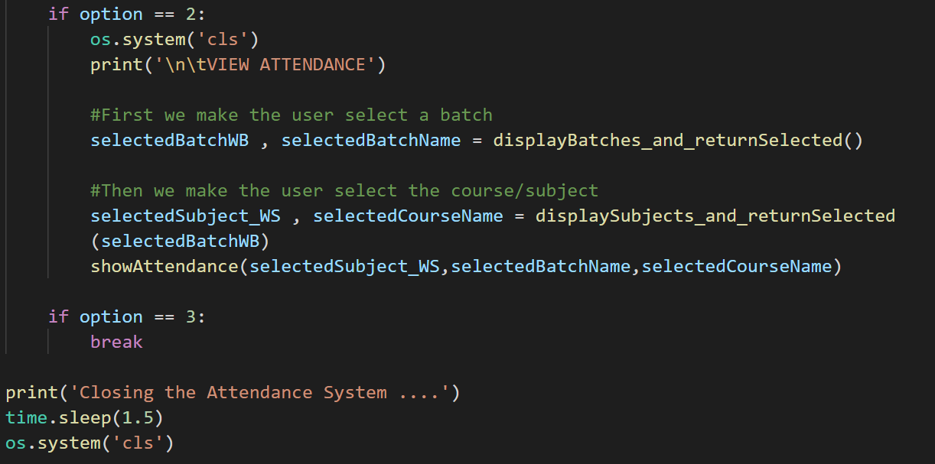

User is asked to select the batch and course whose attendance is to be viewed or marked and based on that info a specific workbook is loaded.Each workbook belongs to a batch and the worksheets inside are of the different courses of that batch.

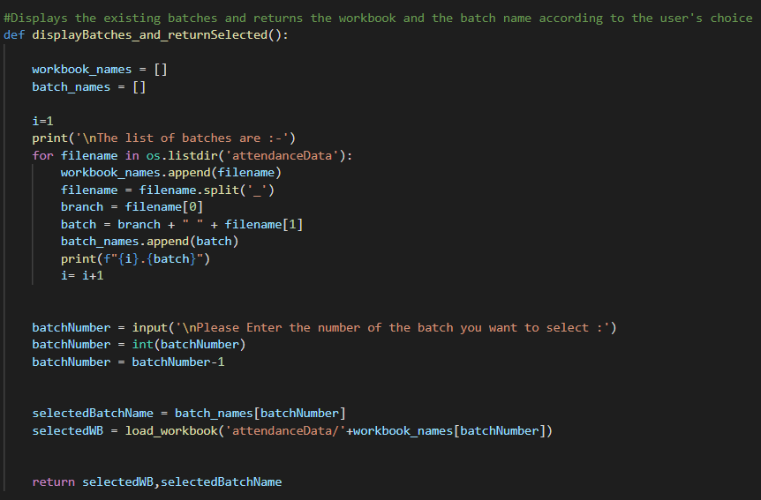

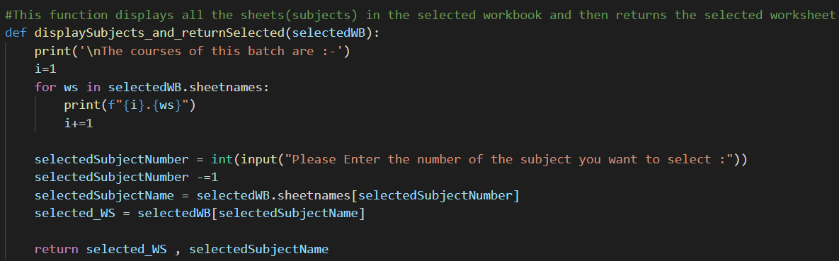

Above two functions load the specific workbook which is selected based on the batch. The workbooks are presaved into a directory with specific names for easy identification.

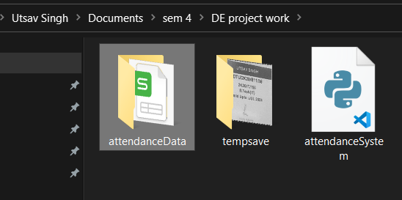

This is the directory structure all the batch specific excel sheets are saved in ‘attendanceData’ folder

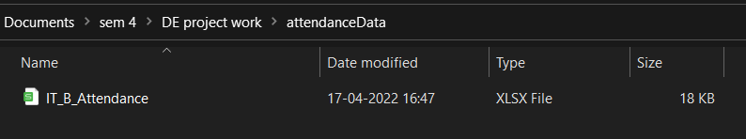

Excel sheet name format : Branch_Section_Attendance

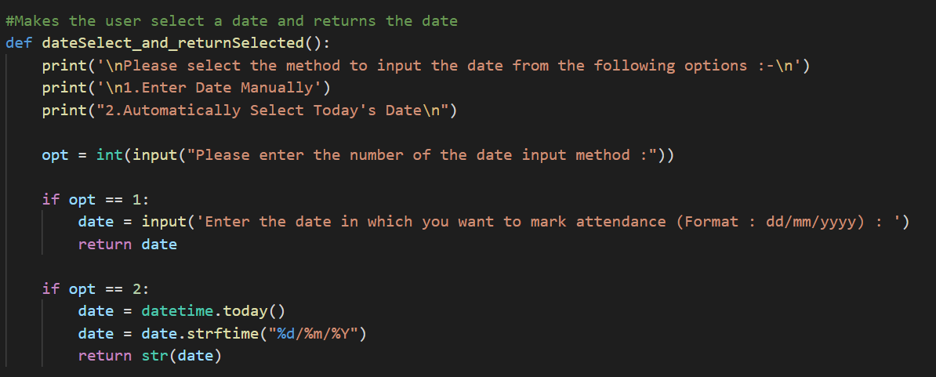

When attendance is being marked the the user is asked to chose a method to input the date , user can chose to automatically input system date or manually enter a date.

After date , batch , subject is chosen the function that collects images ,performs operations on the images and extracts the roll form the id is called.

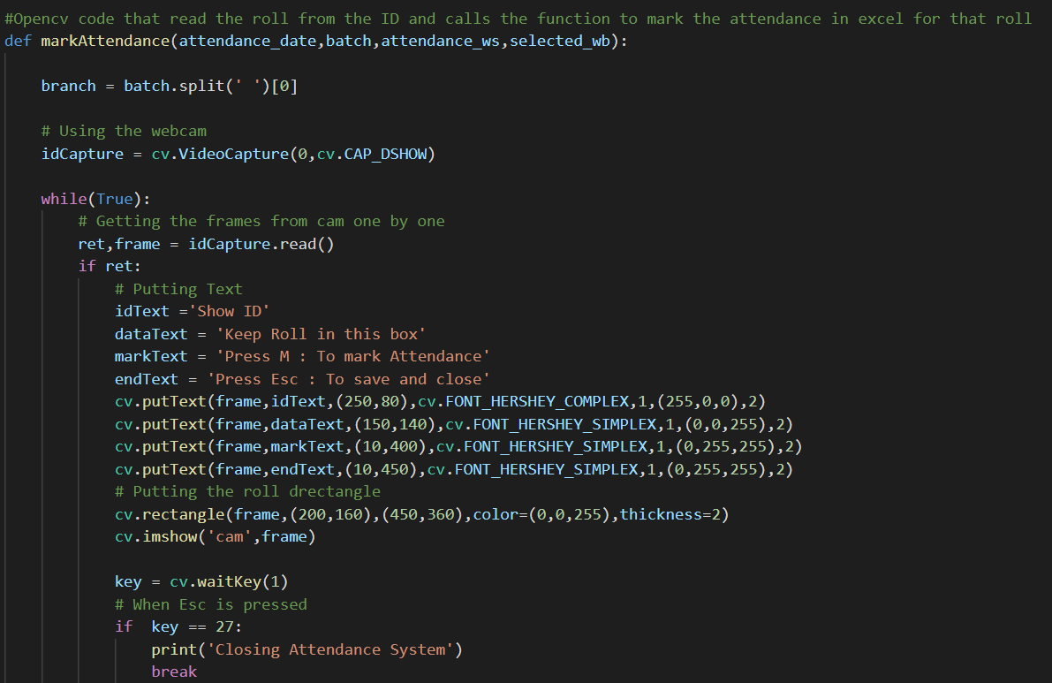

The above code is mainly the UI that is displayed.

Below code collects the image and extracts the roll from it when the keyboard key ‘M’ is pressed.

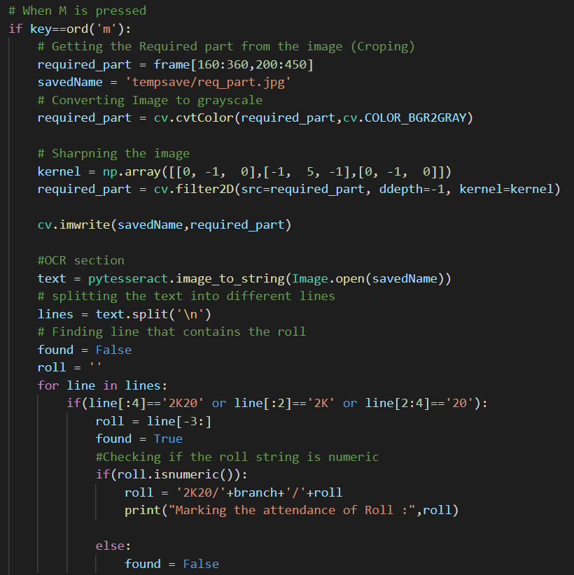

If the roll is successfully extracted this function will call another function to mark the attendance in excel , if roll is not extracted it allows student to try again.

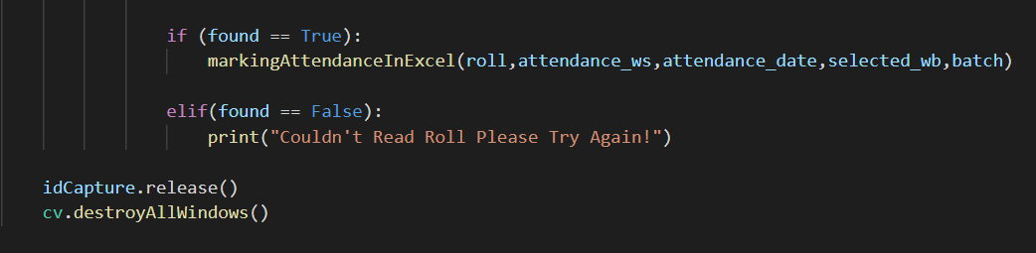

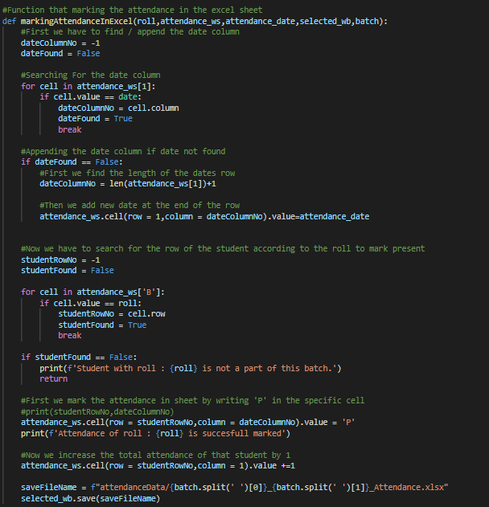

This function marks the marks the attendance in excel and saves it.

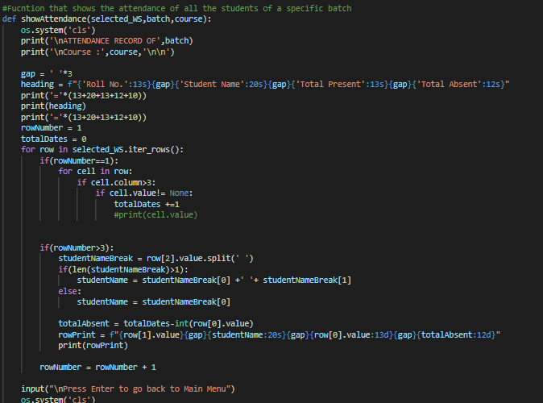

Above function displays the attendance of all students of a specific batch and of a specific course.

**7.Screenshots of working Program**

Main Menu

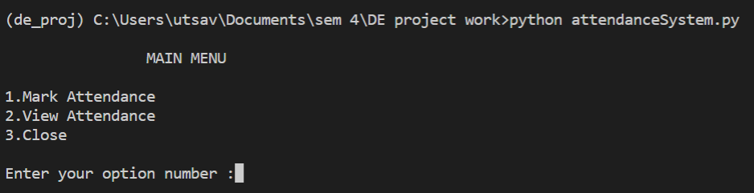

Sub Menus

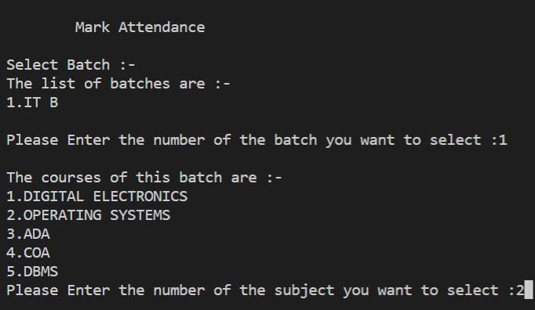

Date input

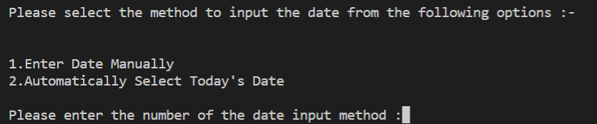

Main UI

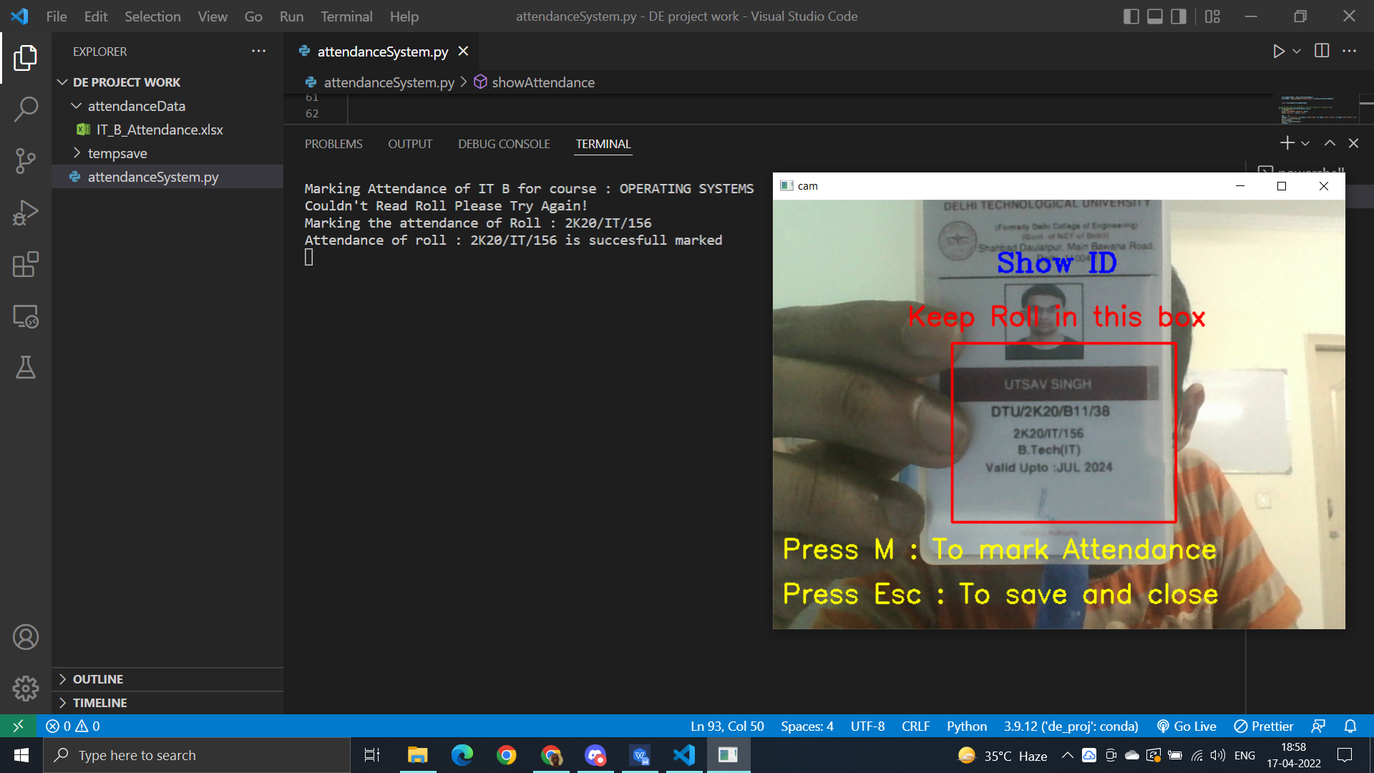

Viewing the marked attendance

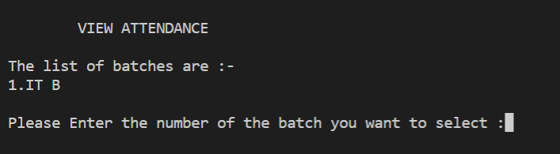

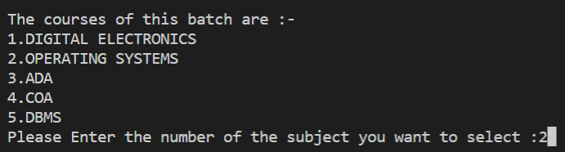

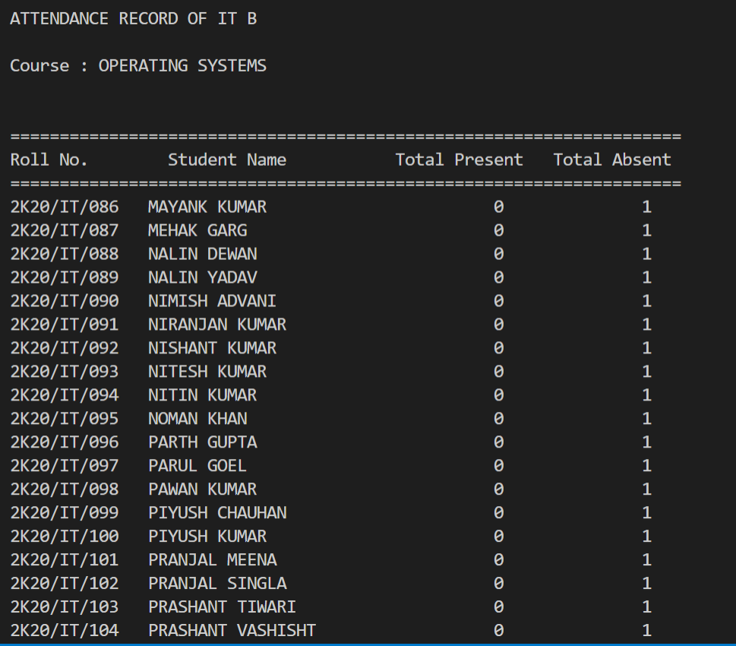

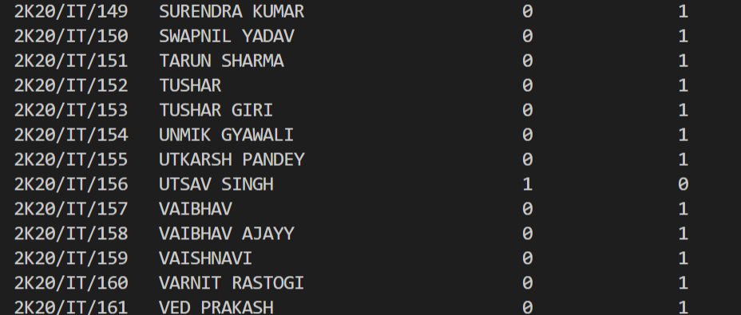

**8.Conclusion**

In conclusion I was able to successfully create an automated attendance system that can be used by DTU to mark the attendance of students without the use of any expensive hardware such are fingerprint or retina scanners.

The required to use this program are :-

1. Laptop or computer with webcam
2. Student with their ID cards.

**9.Future Scope**

There are still some ways that the students can cheat the system which are not accounted for in this program , for example if you have your friends ID card your can mark their attendance , this can be prevented by teacher supervision but goes against the purpose of making the process automated .A possible solution is to match the photo on the ID card with the person that is showing the ID card to the camera by using face detection models , this may solve the issue but will definitely make the code slower due to excessive image processing.

To improve this program in the future will will definitely need to work on this issue to come up with some solution or make some other compromise that still lets us meet our goal of creating a fast ,robust and fully automated attendance system .

Another thing I would like to work on is the UI and create a better looking program.

**10.Documentations of Modules Used**

OPENCV - https://docs.opencv.org/4.x/

PYTESSERACT - https://pypi.org/project/pytesseract/

OPENPYXL - https://openpyxl.readthedocs.io/